21_March_2023 Aron_Lilly8.9_Schertl - Court Amberg Won Trial Acknowledgement Yellow_T_Shirt_Letter

collaborate with Town Duluth Court.my boss „John_David_Essex.

InFamous4+ John_David_Essex ( Arae 10.8 ), Aron_Schertl ( Lilly 8.9 ), Donald_J_Trump, Diana_Ramiresz_Anaya. Each of us is Souce_Spirit. In order to understand that read:

„ Jay Essex - Creation Series 1 2 3“, „YouTube.com/Jay-Arae-Essex“, „Elena_Danaan - Gift from the start Alien Races“, „Dr. Michael Salla - Space Focre“. „Kerry Cassidy - Project Camelot“. „David Wilock“, „David Icke“, „Dr. Steven Greer“. „Coorey Goode - TheSphereBeingAlliance.

The named organisation in those book, webpages, videos are training at paciific_ocean with Donald_J_Trump SpaceFocre. The training is starting also infront of Nation:Spain ( Diana_Ramiresz_Anaya ) around 15_March_2023. Training also happens around Yellow_House_it and Duluth_House_it. Only in terms of InFamous4+. The son of John_David_Essex builded is and is bulding the SpaceForce tending to Donald_J_Trump ( is sstill president, 06_Janaury_2020 ).

The G20_Meeting_in_India_2023 comes from my request to Donald_J_Trump and John_David_Essex my collaboration_partners and bosses. For that rings_colors to show it. Black for ARAE. White for LILLY. Red for Donald_J_Trump. Green for Diana_Ramiresz-Anaya. Read Yellow_T_Shirt_Letter of 16_March_2023 from Aron_Lilly8.9_Schertl. The LIlly8.9 is confusing, but makes sence.

The day of the poison_attack, was that day of „black female shoe“ at village: Atzmannsricht. My father Hans_Johann_Schertl is completly planning this together with corrupt police in Land.Bavaria ( death of police_men Karl_Hilz ), and US_Grafenwöhr_Military_Base. My mother Mariola_Schertl gotme that job ( cleaning at Custodial_Enterpreise ) at Netzaberg elementary_school and in US_Grafenwöhr_NATO_Military_Base at elementary_school. They teachers can be questioned. Soldiers tried to kill me during at cleaning elementary_school alone. Hans_Johann_Schertl is also trying to kill me. They work together, they will not stop killing me. 16_March-2023 the US_Military_Police_Grafenwöhr drove alongside the Yellow_House It. Aroud 03_February_2023 Land:Bavarian_Police driving alongside Yellow_House_It are proteting my father Hans_Johann-Schertl, trying to put me into jail and psychatry. The do the same with InFamous4+. They tried to kill us at the same time, succeeded with Karl_Hilz the Land.Bavarian police_men. Michael_Ballweg ( we were in contact ) from Querdenken_711_Stuttgart is also inrprisoned as Querdenken_Weiden_Chief guy. Markus_Hains from Querdenken_/11 and Rald_Ludywig and many more are fine. They are also targeted by my mother Mariola_Schertl making here about this. As they also attack Harald_Lesch. I was, I am, and still am contact with them. My Yellow_House_it_Family ( also They, and brother Arthur_Schertl ) are miss_using my internet_letter_traffic and so much more. Then they probably contact the CIA, US_Military_Grafenwöhr_Base, or likewise. Exactly the same as „Life and Tmes Michael Prince“, after the thunder I stayed at home as Max_Spiers, Consciously doing nothing, as my spine is broken, up the eye the brain_cells are water since the age of 4 years, my body is fulled up with implants and heavy particulars. At 27_March_2023 a doctor should come to the Yellow_House_it.

As I have no phone, no car, no income. My father Hans_Johann_Schertl.

Herr „Ulrich Bauer“ from Court:Amberg took the responsibilty of helping me, and protection me from Hans_Johann_Schertl_Group. They will not stop killing me. I am under „protection“, but they do not speak with me, no_one. My father Hans_Johann_Schertl is non_stop trying to kill me, and my sister Alegra_Schertl. My mother Mariola_Schertl is saying nothing. The same was done to my sister Alexander_Kapfhammer, he has done the same with his mother/father being accussed and sentencd guilty from each of his siblings ( he has around 8 ).

I need help. I need incom. I need 24_hour_7_day protection. From Donald_J_Trump Administration.

Everything protocolled at the same time from Donald_J_Trum ( Razzia ). My father Hans_Johann_Schertl destroyed my stuff in my roome. Luckly my computer and itnernet does still work at 21_March_2023 ( heavely damaged ). He is extreamly sadistic and brutal, be careful. Read Court:Amberg letter 3_XVII 62/23.

I need protection in house, and witness. I need help to sent the Yellow_T_Shirt_Letter as my boss John_David_Essex ( Town: Duluth, Alliance_of_LIfe, Sphere_Being_Alliance, SpaceForce, TheSpiritualFoundation.com, .... ) is talking about me in his videos. I helped him, he helps me. My mother Mariola_Schertl told to me „Erik“, then my boss John_David_Essex talked about „Erik from Denmark“. Diana_Ramiresz_Anaya is also my boss. As Donald_J_Trump. We are Source_Spirirts and more ARAE, LILLY ( important for Gaia_6_Earth_Age and Soure, acknowledged at Court:Atlanta „Jay Essex - Creation Series 1, 2, 3“. His organizations are training at Pacific_Ocean, as they are also starting to traing at atltantic_ocean infront of Mediterrean_Sea_Passage Nation:Spain and Nation:Morroco.( Diana_Ramiresz_Anaya is repoening TheSpiritualFoundation.com location also in Nation:Spain for her protection as she through the same as each one at InFamous4+ does ).

Training also happens above Yellow_House_it and Duluth_House_it. They can not land, but obsevre the air and space, land. Since I requested help ( Land.Bavaria is US-Territory, Donad_J_Trump is US_President via that US_MIlitary_Highest_Leader, also his SpaceForce and more ). That help is justified due to satellites_shotes and 2_bomber cycling the house around April_2021 ( read „Die Amberger Zeitung ), coming from US_Grafenwöhr_MIlitary_Base. I am the same target as John_Davvid_Essex ( Jay_Arae10.8_Essex ) being that main_part of LILlY ( 8.9 Trillio continouse lives still in my continues life )( fully reincarnated, never left my home ) John_David_Essex is talking about.

I am the same as he is, just in terms of Original_LIlly continousely reincarnating, so his LILLY mentioned in „Jay Essex - Creation Series 3“. I fully handle the situation. Support would be nice.

I also established a phone_emergency_system April_2021 via Coorey_Goode-TheSphereBeingAlliance April_2021 together with Donald_J_Trump SpaceForce. I request and demand as a Land:Bavarian-citizen that United_States_of_America is protection me, as they are taking that responsibility since 2_World_War from Hitler_Germany. My life, as the life of many is continously attacked. They will not stop. I hope Donald_J_Trump, John_David_Essex, Diana_Ramiresz_Anaya, will sent help to the Yellow_House_it and stays here. Only loyal to InFamous4+, not Non_Defense_MInister of Non_President_Joe_Biden, or corrupted Police_Men/Solider from Hans_Johann_Schertl_Group.

I will sent this to all attorneys, newspapers and more I fine. Together with the Yellow_T_Shirt_Letter. Many moer details are explained there. Additionally i have become one of the leader of the Alliance_of_Life, Sphere_Being_Alliance and way much more. Even in power and more the strongest prime_minister. I can prove this. As G20_Meeting_in_India_2023 comes from me, and InFamous4+. As police_men form City:Auerbach ( head_police_station of village:Großschönbrunn ) acknowledged „Yu Gi Oh - Master Duell See It“, and „Nividia RTX 4000 Graphic Card Series“. Hans_Johann_Schertl is using the Yellow_House_it_Arte De/FR_Mit_offenen_Karten for himself. I predictaed that as CIA/FBI/and_more overtaking ( CIA Razzia with Donald_J_Trump in Miama, at same time Hans_Johann_Schertl destroyed my room, computer luckly barely still works ): Police_men City:Auerbach is my witness.

In terms of satellite_shoots and house_razzia and more: „YouTube.com/Jay-Arae_Essex NSA_Affiliation_TR4“. They do the same with me, as they do it with InFamous4+. Also James_Rink, Johnathan_Rich ( dead as same time as Karl_Hilz died ), as Michael_Prince and many more. Pete_Peterson is also dead. I need to continue my work, otherwise I am dead. „Russia bought 1000 drones from China for securing the Russian_Borders“ after I gave that idea to Donald_J_Trump 45_Office.com. Everything prove_able via my Internet_IP_Adresse of my browser history of browser „Mozialla FireFox“. I gave a part of Yellow_T_Shirt_letter to second major of municipality: Freihung „Klaus Siegert“ my neighboor at Hirschauer_Straße_9, i life at Hirschauer_Straße_5 village:Großschönbrunn. My father Hans-Johann_Schertl was not pleased and attacked me, the police was called and came to the Yellow_House_it. The are telling that my father Hans_Johann_Schertl is the victim. Watch for this Karl_Hilz, Michael_Ballweg ( Querdenken 711 Stuttgart ), Dr_Reiner_Füllmich „Außerparlamentarische Stiftung Corona Ausschuss“.

My mother Mariola_Schertl, brother Arthur_Schertl are the same as my father Hans_Johann_Schertl. Keep your distance and be careful when the interact with you. They have something to do with Annunaki_Family shown at Youtube.com_Banner_Annuanki short after Youtube.com_Banner_COVID_19 has started. I am creation_wide awake in sum of 8.9_Trillion lives since summer_2021, John_David_Essex can attest that, as I released from his inprionment in terms of deawake, deascended. I even „not fused, but better“ got his human_Body functional with „Dracks“_property. Dracks from TheSphereBeingAlliance. We both are leaders of them.

That was just idiot_luck that I found him. As I found Michael_Prince. We are getting thinge done.

Bill_Gates even was in NatioN:Germany and bought after my Yellow_T_Shirt_Letter Nivida with their new RTX_4000_Graphic_Card_Series coming form me. Watch for that Yellow_House_it_Merkaba_Datacube. The most humans will be „awake“ soon. So you will start to understand. The more John_David_Essex wokr is known as him, the sooner and easier it is.

Please sent this letter and Yellow_T_Shirt_letter to all attorney, parlamentents, everything in cities and more. As prove: After I sent this Letter to german working_assosciation „IG Metall“ their new_leader was elected and he comes from City:Amberg. My Yellow_T_Shirt_Letter works. Read it, and look_up those technologies and way much more. Like from Pete_Peterson and David_Wilcok. It is not my fault that no one is capable of reading physica, mathematic, engineering scientific_papers, and machine_bulding_Plans, then telling that they know everything. The think that they are the master of all lviing being. A guys named the name of the race „pleiadens“ and was put into jail and psycahtria.

Each docotr, lawyer, and more doing those pratices will lose their liscense and will be inprisoned in a proper way. They are the as the worker of „Adolf Hitler“ of Nazi_Germany. Compare the parallels. Mass_Murder with COVID_19_Pandemia and COVID_19_Vaccination. They also forced me to put that poison into my body 2-times of company:BIoTech. Luckly I got ride of them since 06_January_2020_year „ Yu Gi Oh - Blacked Eyed Dragon Card“ via lawsuit, as a whistleblower to „Dr Reiner Füllmich“.

I am a main part of the Source_Field and more called „LILLY“. This no a describtion of gender. Is describtion of living fields and much more complicated of Original_One_Beings_Female_Half ( it is called that way, but not a gender! ). How can humanity not know this. This is standard knowledge. Read those books. My reincarnation gender is male, as I have a penis. I never told something in a differnt way. Beings are lying as good as possible. The are evil, as brutal, and more as for thei own need necessary. Killing 5 Billion Humans was screamed by my fahter Hans_Johann_Schertl and praised to the heavens. He also told to me around 03_February_2023 after the 4-police-appearance of his police-call, that he and many more will come_back with „high energy atellary space/ari_craft“. How can he know the exitence of such technologes. He is never using the internet, nor taling with engineers, only watching Germany-Television ( there it was never told ), of technologies like „Dr. Salvatores Pais“, „Pete Peterosn“ and more space_enginees or air_enginess. The police_men of the 3-police-appearance want to put me into the psychatry, and praised the „Reset“ apparently the „Great Reset“ caused of corrupt „COVID_19 Pandemie“ of „World Economic Forum“ and many more. For that „Dr. Reiner Füllmich - Außerparlamentarisch Stiftung Corona Ausschuss“. The phone_number of the Yellow_House_IT is 09622 71108 or 09622 3408 ( DasTelefonBuch. Com with address of Hans_Johann_Schertl ), I ask this to those guys walking in the Hause and Yellow_House_it_Property since 20_December_2020 and sincet he age of 4_years being born 28_August_1996. The twist and turn everything, and get everything wrong. As the never spoke with me. Not even one phone_call or talk yet. Also not in terms of „Jay Esse x- Creation Seires 1, 2, 3“. Already proven by Source, and more.

„Is it female or male? It is female-spirirt of source main-part of LIlly“, told from John_David_Essex ( Jay Arae 10.8 Essex ) in „Yellow T Shirt Videos of YouTube.com/Jay-Arae-Essex“. No_one talk with me. So no_one understand the phone_line_trick with main_phone_line_Trick_possessor.

It is end of third_cycle, if it would be a thing, I hope that all of them and their fleets, military_bases and way much more also in terms of contracts, and advancedment and all perspectives failed the third-cycle for ever“. If hell or heaven is a thing, according to pop Benedict_the_16 catholic_roman_church. I hope they will end up in hell. Just alone for „Life and Times - Michael Prince“. There is so much to tell. So come to the Yellow-House_it_property. Once my father Hans-Johann_Schertl destroyed the internet_router, or my computer, as he will not stop destroying me stuff. And I have no transporation and income. Read court:Amberg letter „3 XVII 62/23“ 17_February_2023.

Only my boss „John_David_Essex“ is allowed to touch me or evaluated my situation and more.

To each evaluation, John_David_Essex needs to give his evaluation. I reject_everything. I know how t that wrong_evidence and wrong_work, and so much more, the same methods as fomr „Adolf Hitler“. I grew_up in Germany, no_one need to tell me that the now_a_days Geramns have no „Adolf Hitler“ issues. Their behaviour is still the same as before, during, and after „Adolf Hitler“. The strongest sompanies in Nation:Germany now_a_days at 21_March_2023 are those who have done the „Holocaust“ mass_murder. During the COVID_19_Pandemie ( it started while I tried to meet Harald_Lesch in Municipality:Haar in City:Munich ) and ended April_2021 I got ride of COVID_19_Lockdown via surviving ( as InFamous4+ ) assassination_attempts from Hans_Johann_Schertl-Group. The Hans_Johann_Schertl-Group will not stop to walk inside the Yellow_House_it to asassinated or threaten me. The will of course destroy the Internet_Router_Box, and my heavly_damaged_computers and take all of my things in my room. I request that my Yellow_House_it is under satellite, and air_protection of SpaceForce of Donald_J_Trump, Sphere_Being_Alliance, Alliance_of_Life, and more of InFamous4+. I also need them on the land for protection, income, and court_witnesses 24_hours_7_days. We all know that I get what I want. I won until now pretty much, did I not promise? I know my shit Even if I need to get all attorneys on the net_phone. This is no longer possible since 14_March_2023 as my father Hans-Johann_Schertl destroyed and took_away the net_phone after I spoke on the phone_recorder of Town:Duluth-Court for John_David_Essex ( 00 1 770 476 3434 ) and SpaceForce ( 00 1 703 697 3039, or 00 1 703 695 0640 and writting donaldjtrump.com and 45office.com.

Court:Amberg Herr „Ulrich Bauer“ demands in Court_Sentence, that I get full access and support to communication. As I need to give 24_hours_7_dayss a phone_call and need to be 24_hour_7_days available on the phone_number of net_phone_Yellow_House_it 0962271108 and 096223408. Those are my known „Yellow House it - Incorporation and Collaboration“ phone_number as Yellow_House_it is a brand_mark and companies address, also being under all_kind_of_ways protection. This place is not guarded enough.

Yes, The_Sphere_Being_Alliance is capable, but physical support with income, car, phones, internet_box, computer and way much more is necessary.

I need to sent the Yellow_T_Shrit_letter to all possible conacts. Currently all „biggest law companys by revenue all employess“ or „all american newspapers per state“ and so much more.

Via that InFamous4+ becoem more known. Via that I become more powerful as working as task_field of a prime_minister together with Donald_J_Trump. I am restlees. I need to get John_David_Essex and Diana_Ramiresz_Anaya as known as possible, now. Now! I am on a good way, look_up Yellow_T_Shirt_letter receiver_section. I takes to long.

I need secretaries, also at wintesses and protocol_writers. I need more physical, internet and more contact with John_David_Essex, Donal_J_Trump administration, Diana_Ramiresz_Anaya and many more. But without car, or income and direct_support, that becomes difficult.

21_March_2023 18:44

Yellow_House_It, Aron_Lilly8.9_Schertl

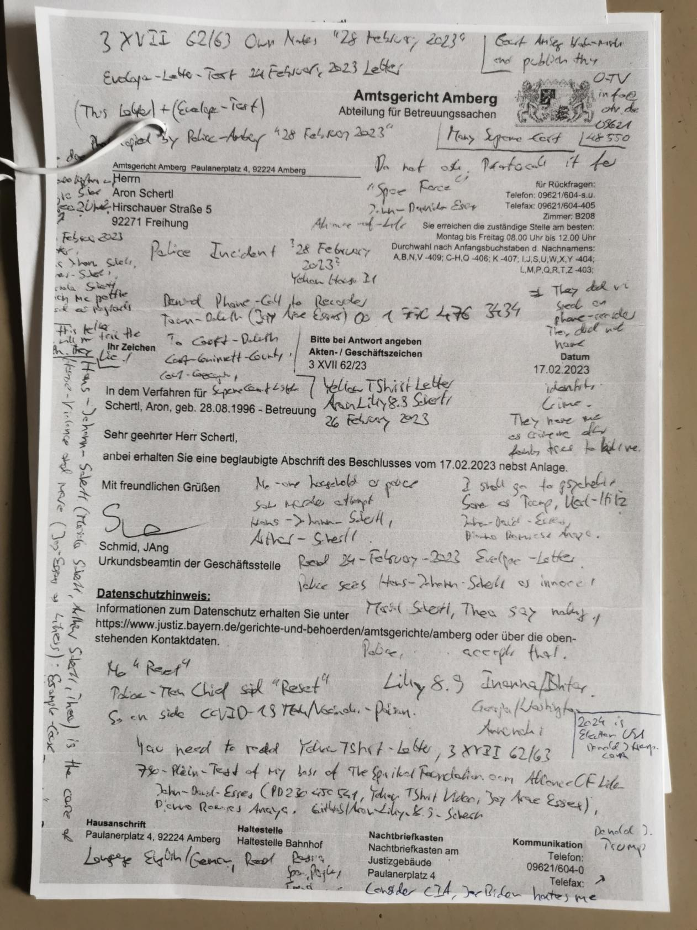

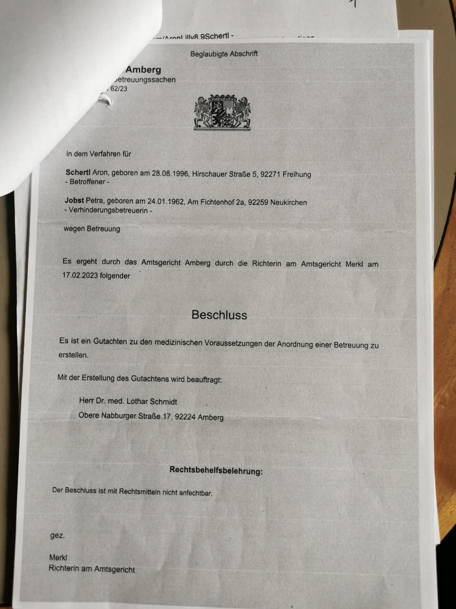

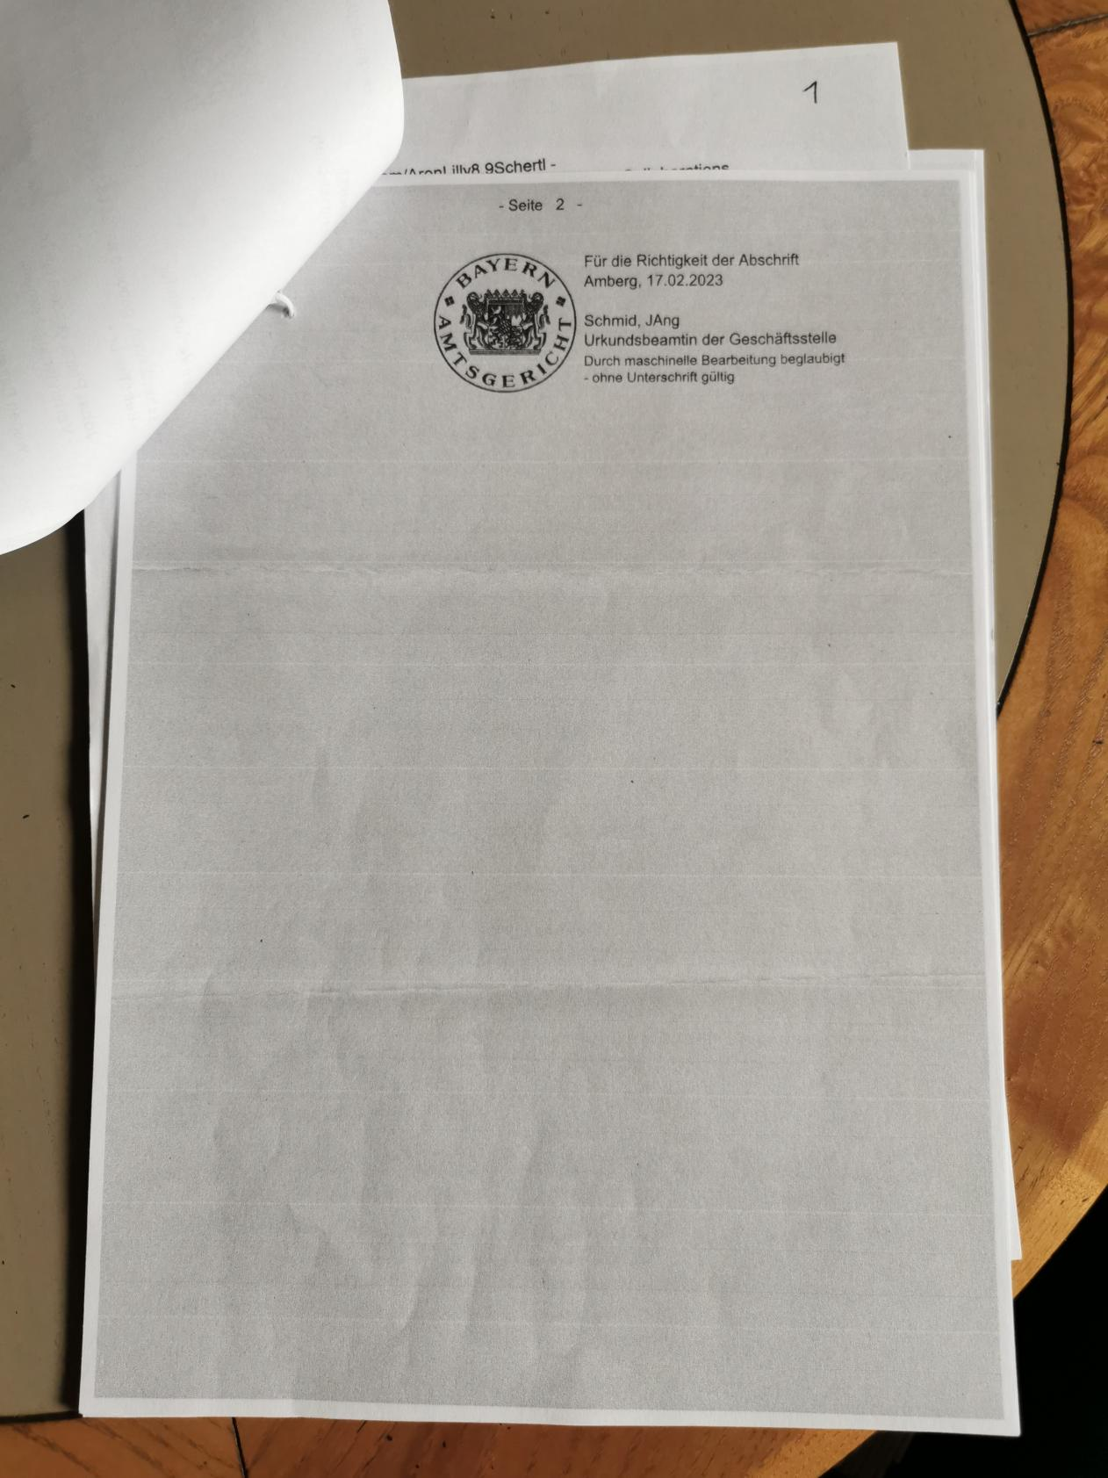

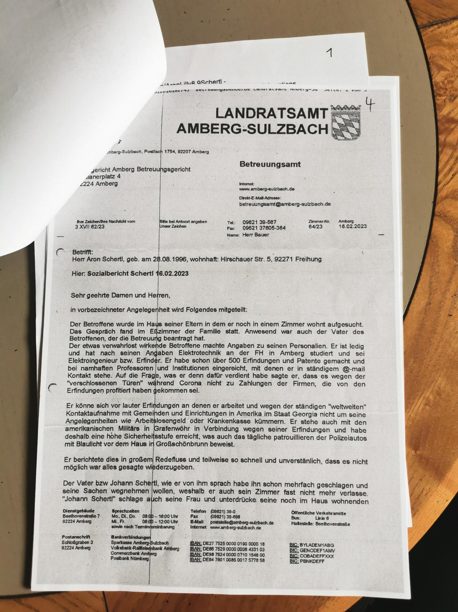

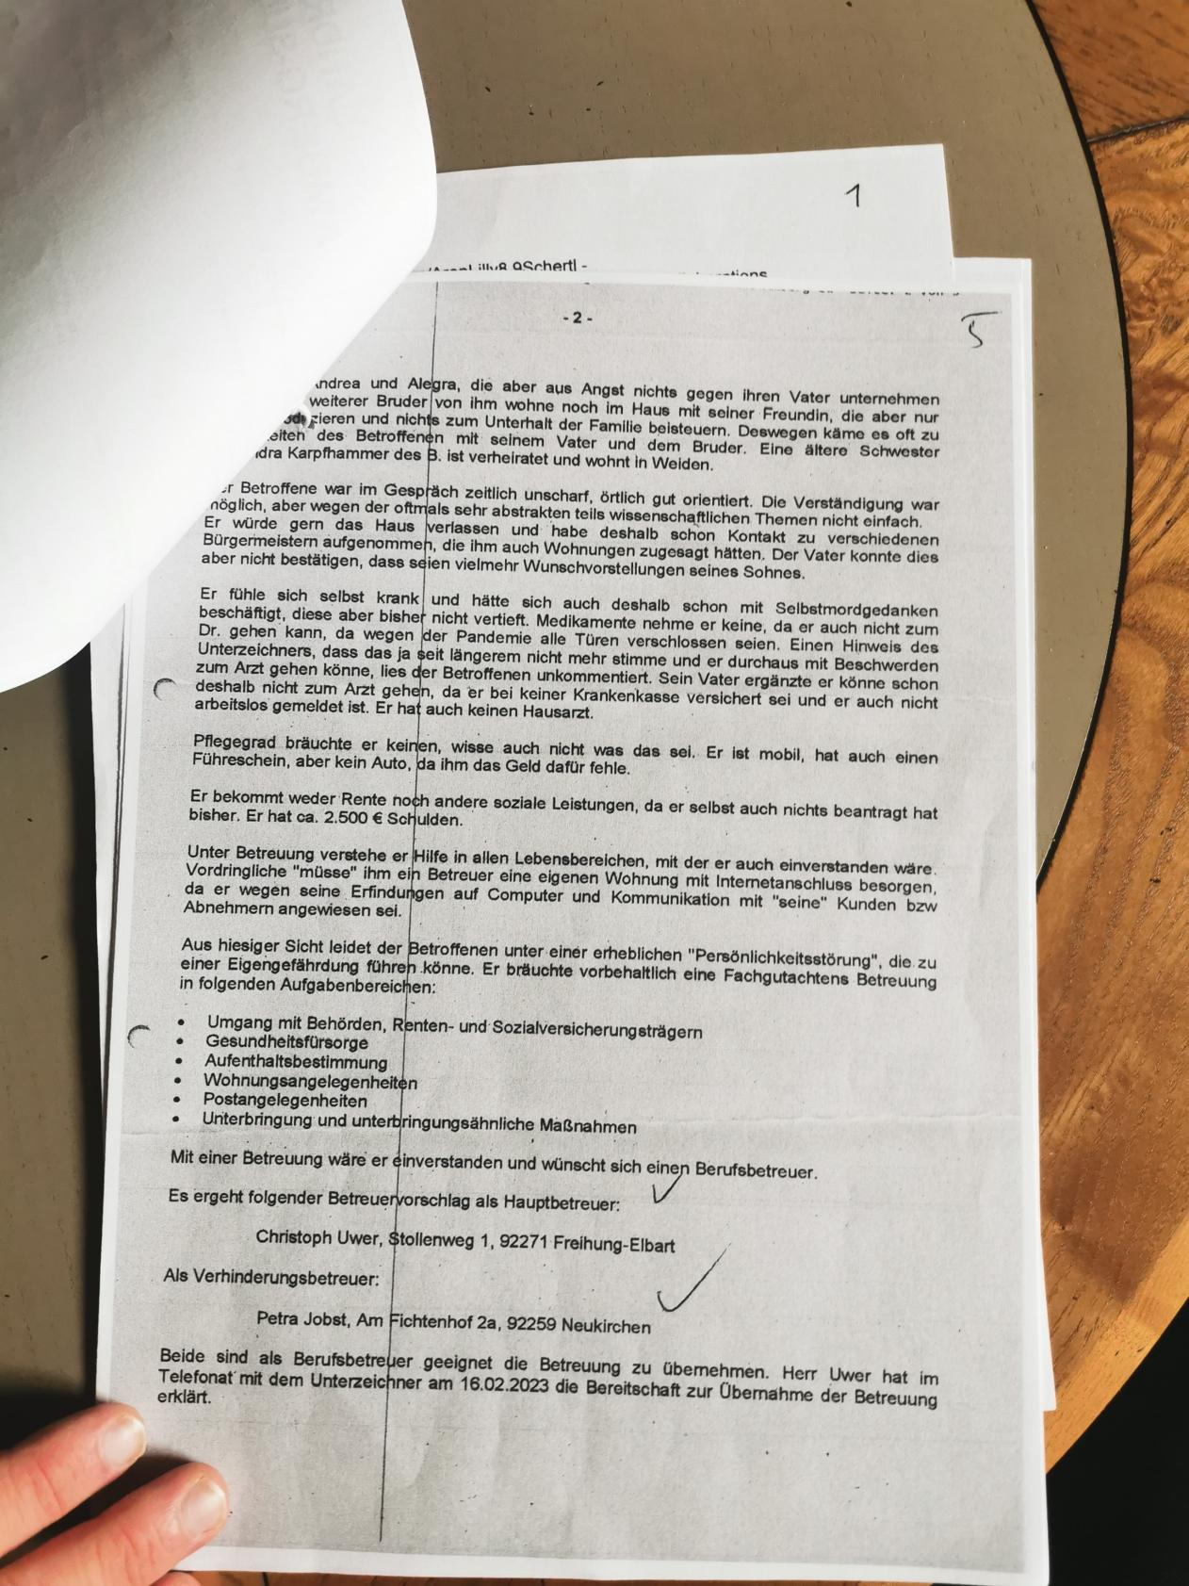

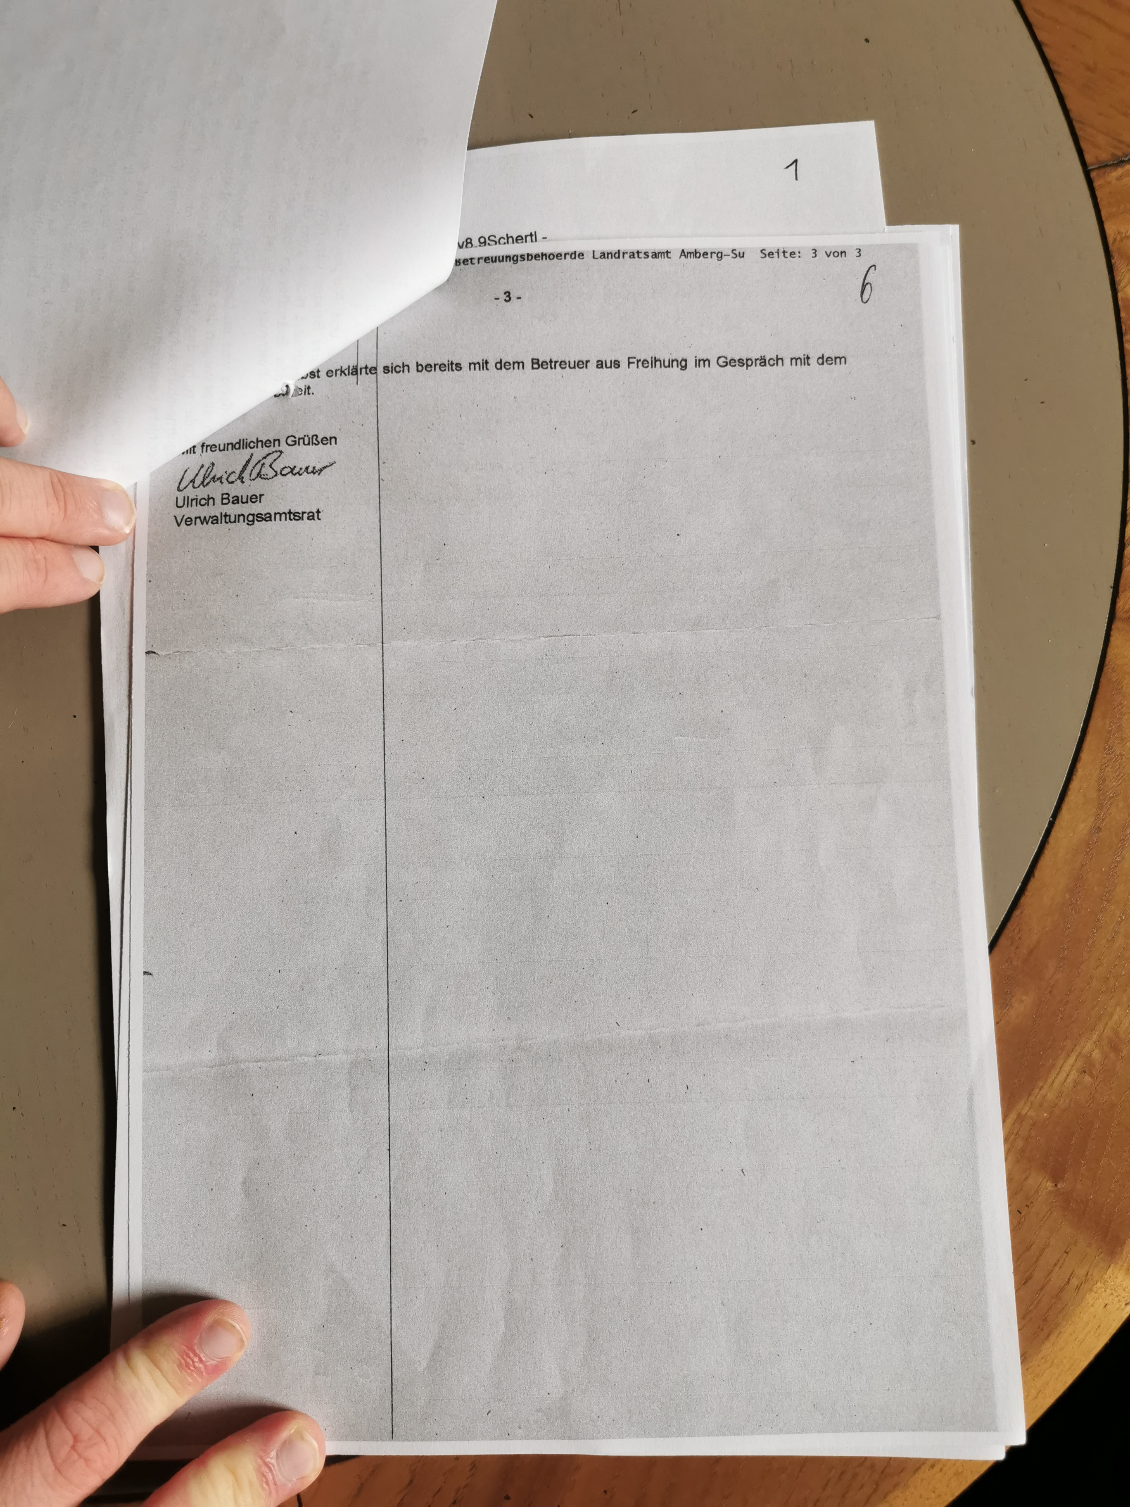

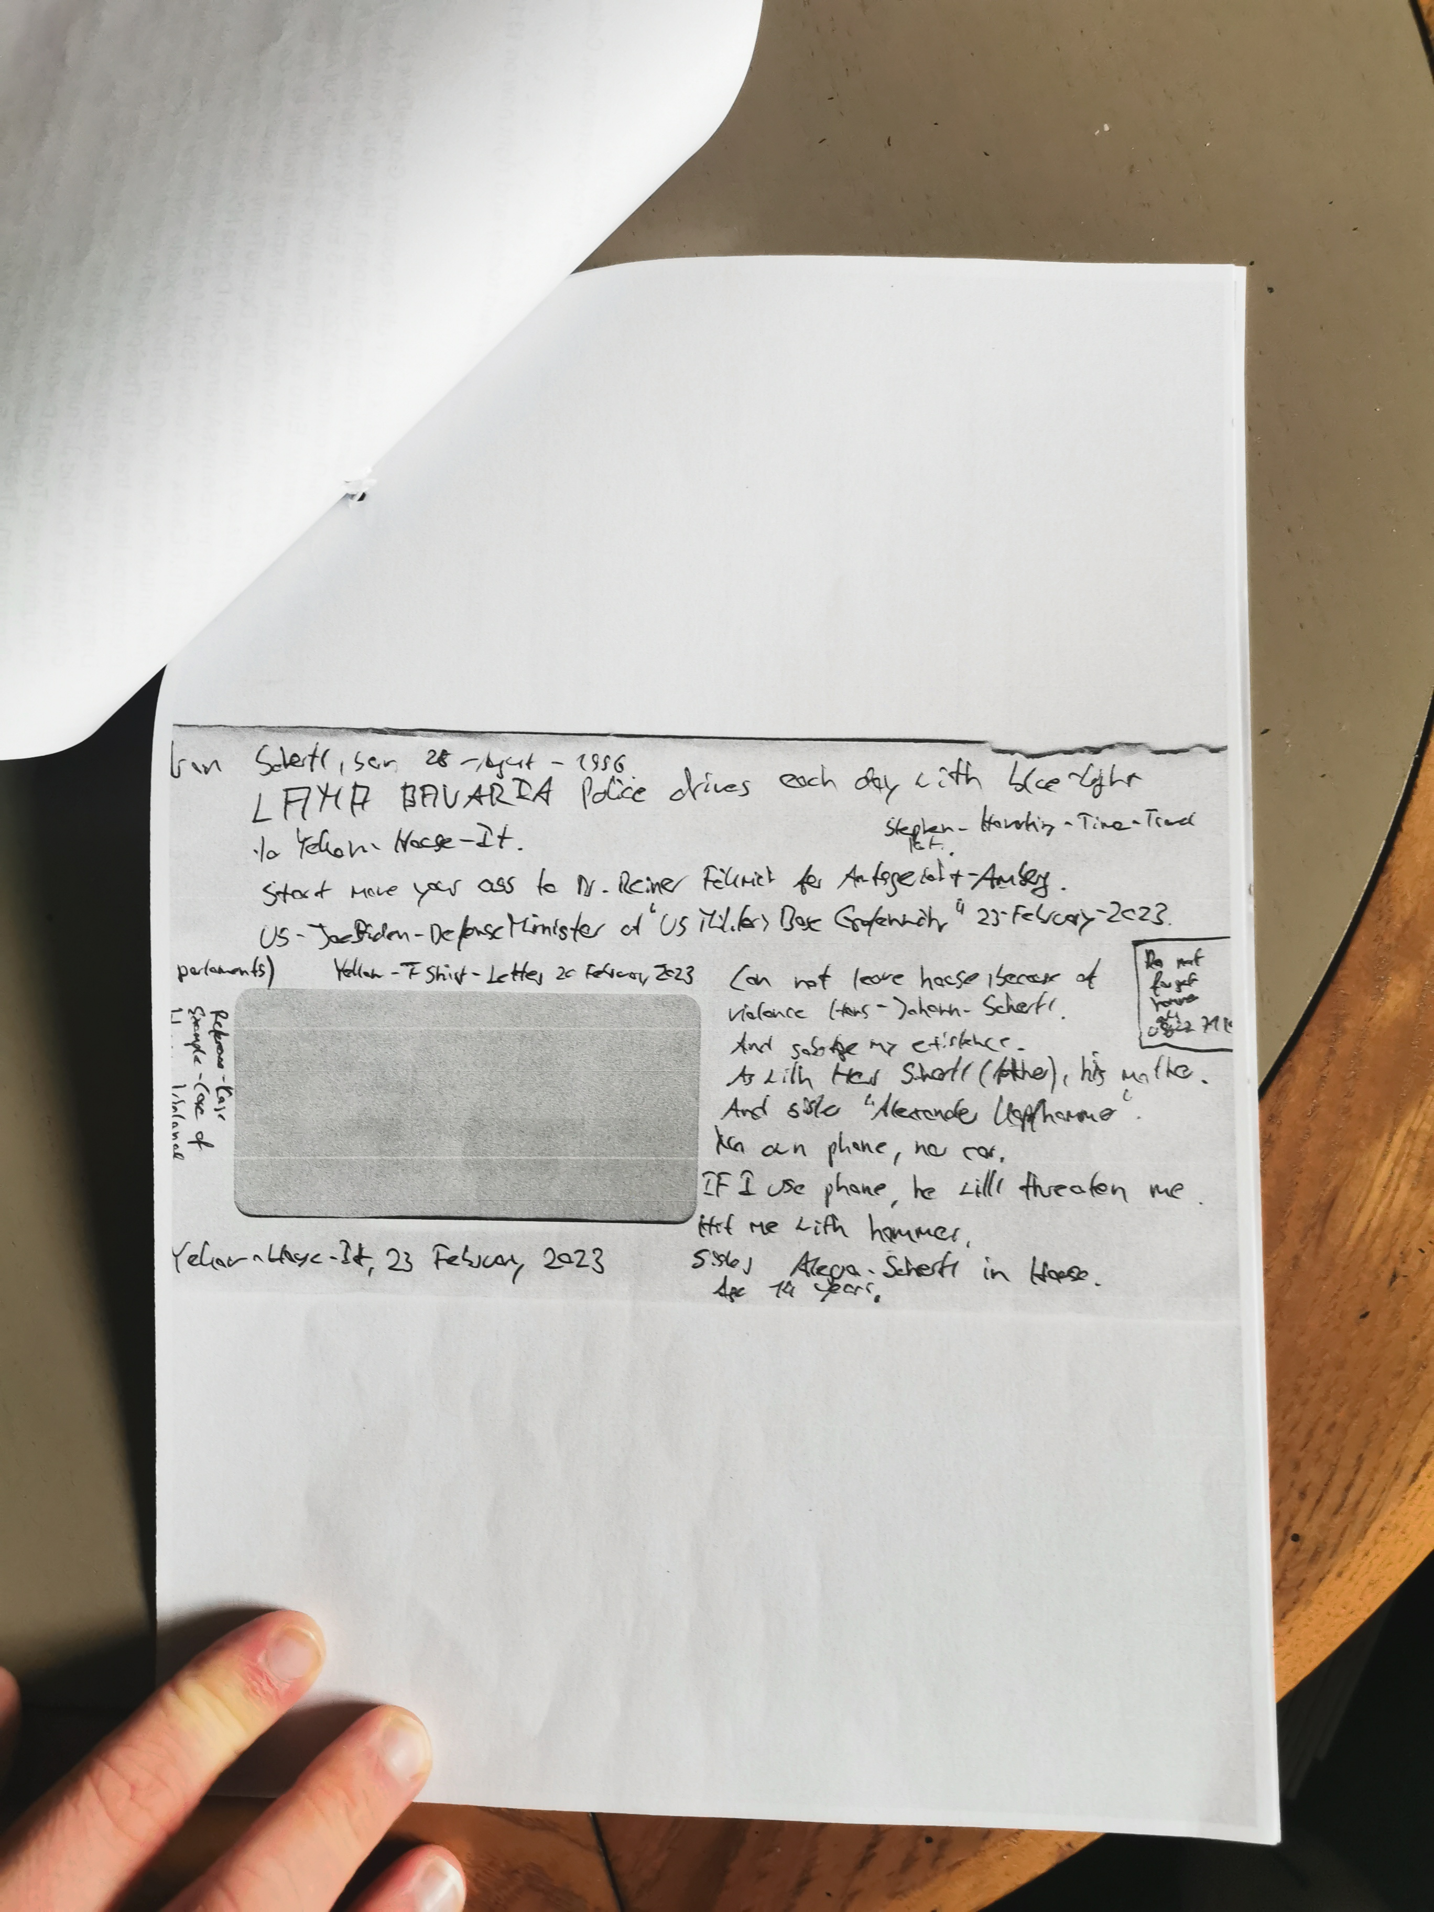

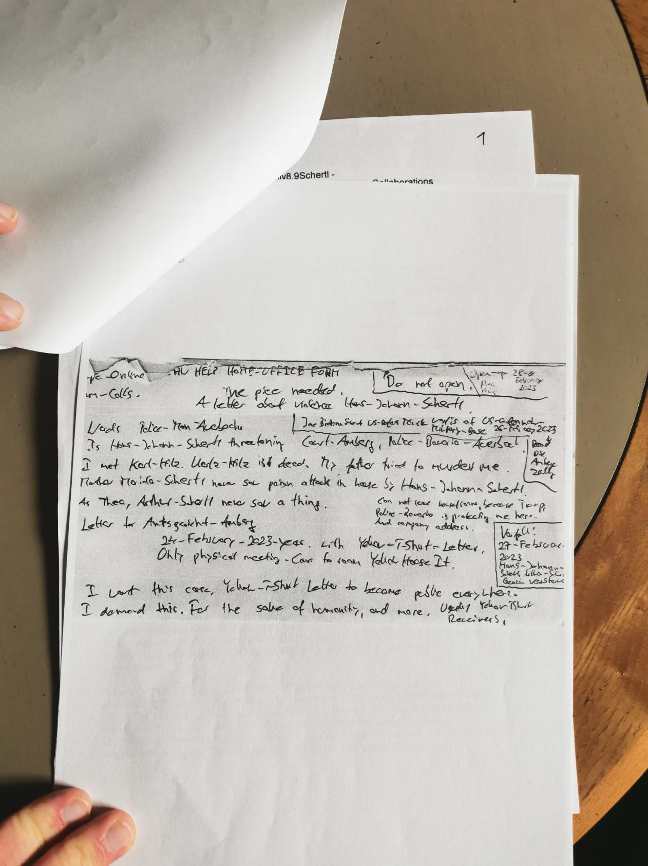

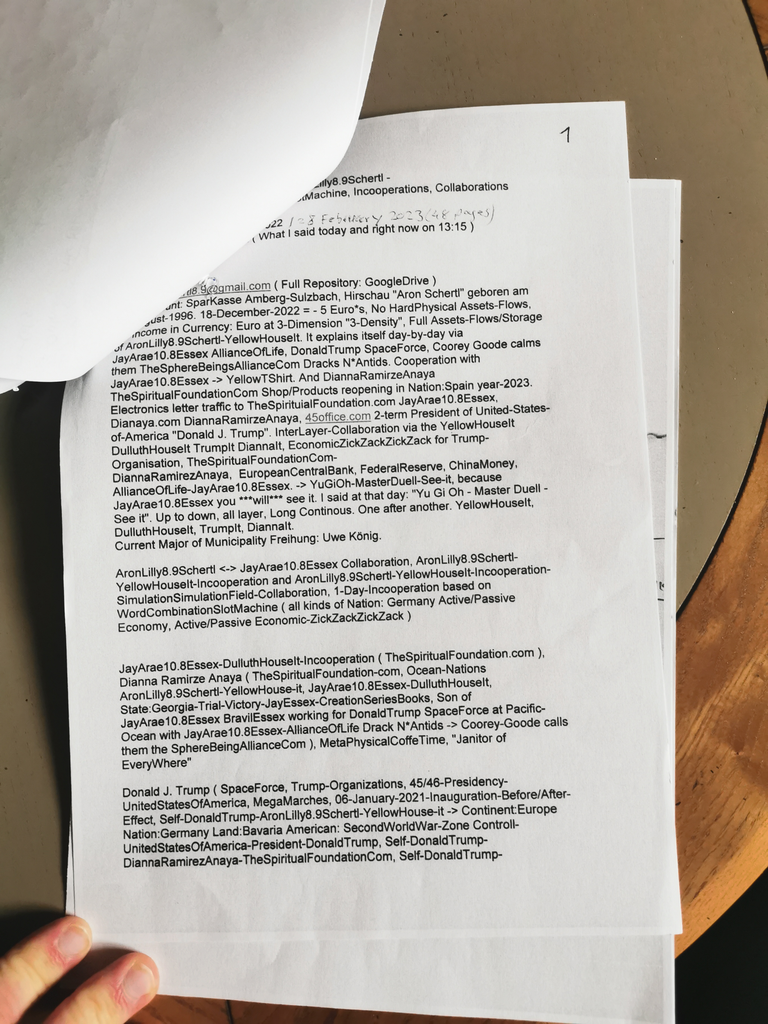

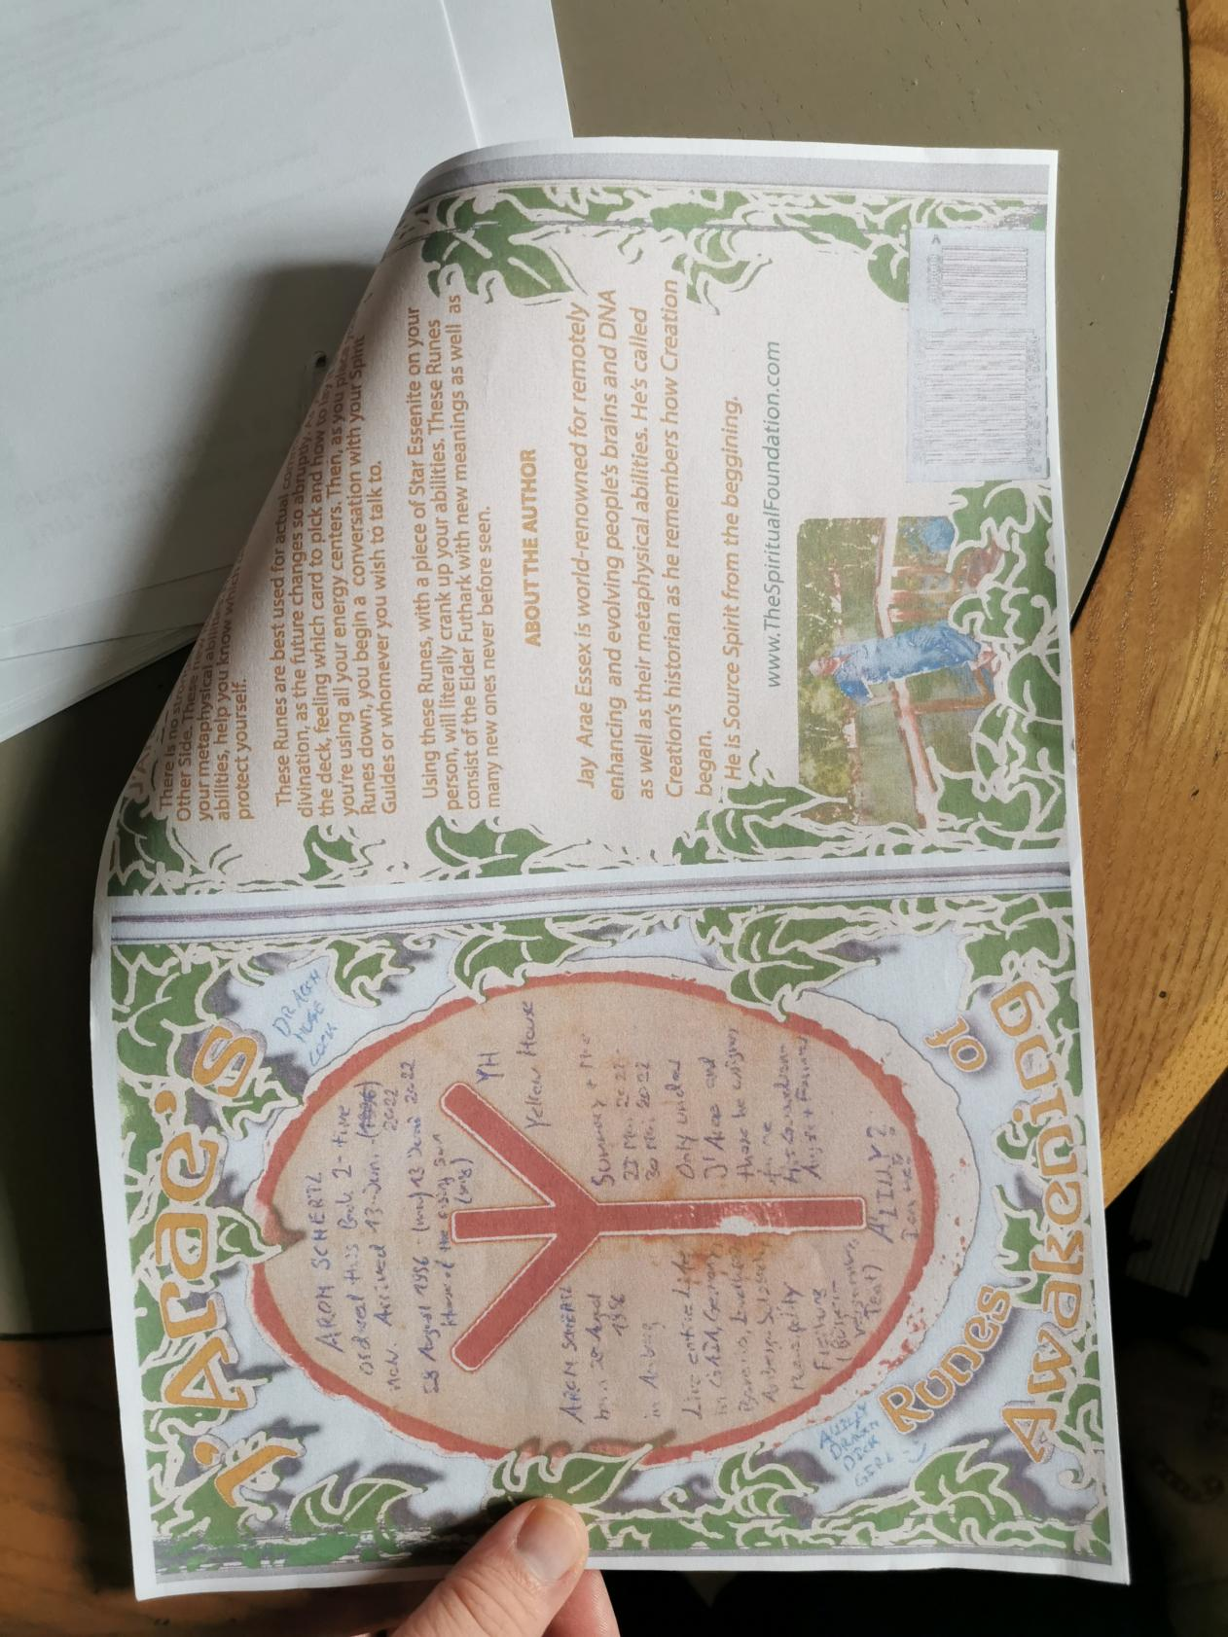

Aron_Schertl ( Lilly 8.9 ) Yellow_House_it Incorporation and Collaboraiton:

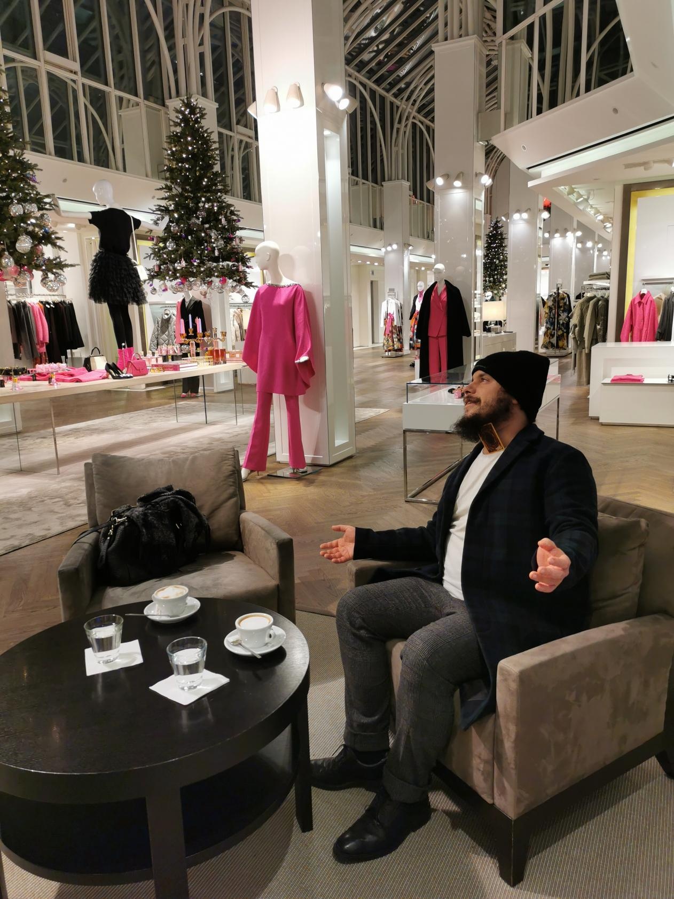

John_David_Essex ( Jay_Arae10.8_Essex ) 27_Juli_1955 born in New_York_Long_Island.

Life in Town:Duluth. I am correspondence with Town:Duluth and State:Georgia, United_States_of_America: Basccally everything, see Yellow_T_Shirt_Letter 21_03_2023.



Mariola Scherrtl -> „Erik von Denmark“.

Donald_J_Trump „President_of_United_States_of_America at 21_March_2023“



Diana_Ramiresz_Anaya

The_Spiritual_Foundation.com. Leader of the Alliance_of_Life. Als Sphere_Being_Alliance.



Yu_Gi_Oh Backside Card, Yu_Gi_Oh-Master_Duell_See_It.

